A1044-MEX-Mezcala, Guerrero-Figurine-Male-Seated-Serpentine-Early Classic-600-900 CE

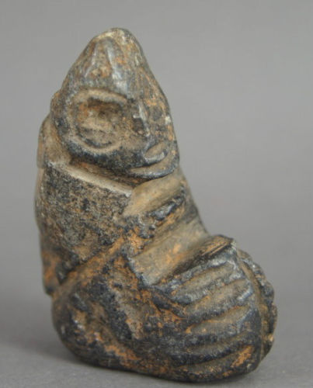 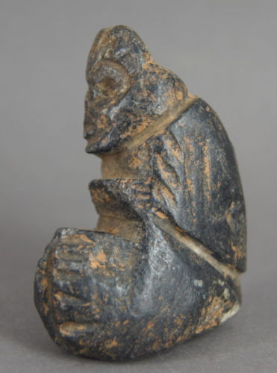 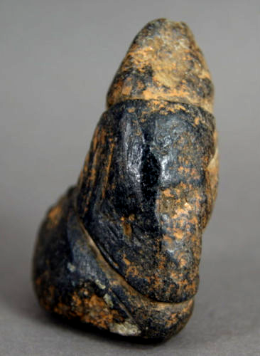 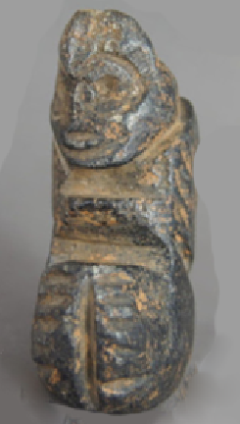

Figs. 1-4. Mezcala, Guerrero-Figurine-Male-Serpentine-Early Classic-600-900 CE

Case no.: 14

Accession Number: A1044

Formal Label: Mezcala, Guerrero-Figurine-Male-Seated-Serpentine-Early Classic-600-900 CE

**Display Description:**

This seated male Mezcala Early Classic figurine probably depicts a shaman. The figurine is wearing a cloak and a distinctive conical cap. Its back is ridged suggesting the spine. Figurines with ridged spines have been found among the Taino in the Caribbean where a ridged spine may signify the movement of hallucinogenic sensations as they are felt to move up the spine. Both hands are depicted as extending forward holding a container possibly of a hallucinogenic potion. Other Mezcala seated figurines with both hands extending forward also hold a small container.



Fig. 5. Mezcala seated male shaman holding a container possibly of a hallucinogenic potion. The figurine wears a distinctive crown. After

<https://i.pinimg.com/originals/>

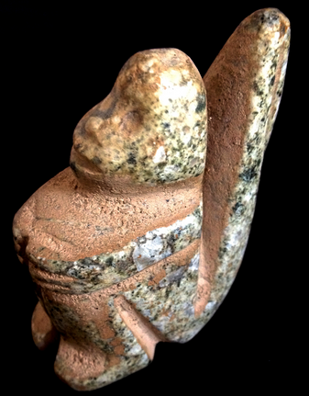

Fig. 6. Mezcala seated shaman transforming into a monkey holding a hidden object, possibly a container of a hallucinogenic potion. The figurine wears a distinctive conical cap. After https://i.pinimg.com/originals/

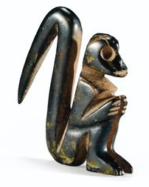

Fig. 7. Mezcala seated shaman transformed into a monkey

https://s-media-cache-ak0.pinimg.com/236x/80/e3/f0/80e3f034e9379ec00b67e4df415d5aee.jpg

These seated figurines are very rare and important as little is known of Mezcala shamanism and of the hallucinogenic potions they may have imbibed.

The Mezcala style was named by Miguel Covarrubias (1904-1957) who arranged small objects of polished stone, peculiar to the State of Guerrero in the form of figurines and masks, animal effigies and ornaments such as pearls, pendants or earrings (Covarrubias 1948, 1956, 1966: 106) into of five major groups of which the Mezcala figurine style was Type 5.

Type 1: Olmec or La Venta style (Chontal) Objects

Type 2: Olmec Style Objects

Type 3: Teotihuacan Style Objects

Type 4: Olmec-Teotihuacan Objects

Type 5: Local Style Objects-Mezcala, schematized pieces

The function of these figurines is hypothesized to be 1) tribute to fertility deities, 2) tribute to ancestors, and 3) consecration of habitations. These objects are grooved using what appears to have been an ax, with cuts and planes arranged geometrically and with facial or bodily features scarcely suggested. The raw material used is generally a hard stone (diorite, serpentine, andesite, marble and obsidian) the color of which varies from green to gray-green or gray. The Mezcala style is not limited to anthropomorphic representations but includes jaguars, frogs, monkeys, squirrel, birds, etc. Also included are miniature facades of temples, stone implements such as rectangular or triangular palettes and axes.

**LC Classification**:  [F1219.1.G93](http://luna.wellesley.edu/search~S1?/mF1219.1.G93+G29+1992/mf++1219.1+g93+g29+1992/-3,-1,,B/browse)

Date or Time Horizon: Early Preclassic, 700-200 BCE

Geographical Area: Balsas, Guerrero, Mexico

**Map:**

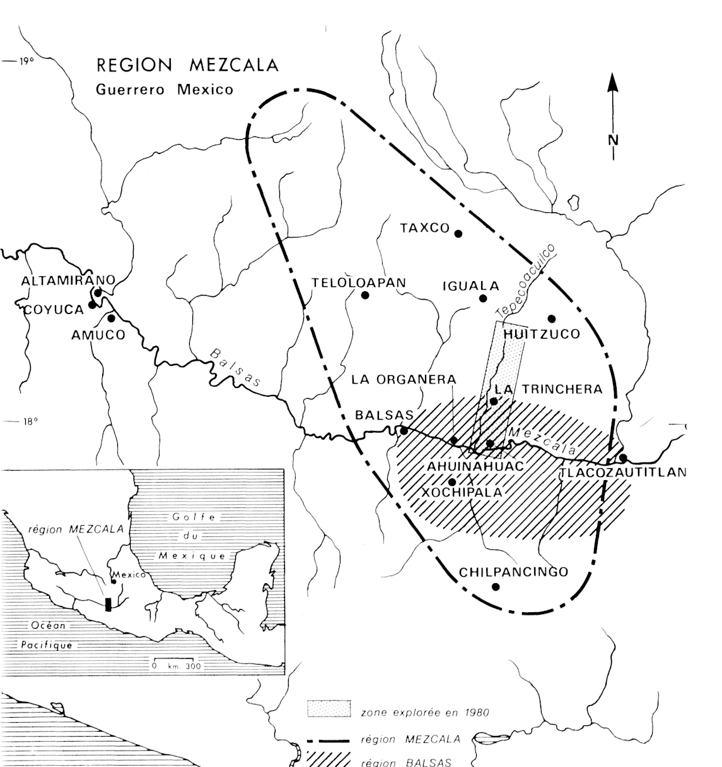

Fig. 8. Map of Guerrero, Mezcala, after http://www.samildan-art.com.

**GPS coordinates**: 17° 55' 00" N, 102° 10' 00" W

Cultural Affiliation: Balsas, Mezcala

Medium: green andesite

Dimensions: H 2.2 in

Weight:

Condition: original

Provenance: from an old collection of Mexican archaeological objects.

**Discussion:**

The definition of the Mezcala styles has been diverse. For instance, Carlo Gay (1967) restricted the Mezcala style to schematic objects dating them to the Preclassic Period. Serra (1973) on the other hand, established another classification focused on anthropomorphic representations.

Ritual re-appropriations of Mezcala votive objects outside the Mezcala area have been found in:

1. Teotihuacan (Rubín de la Borbolla 1964)
2. Xochicalco Valley (Noguera 1961; Sáenz 1961, 1963). A Mezcala anthropomorphic figurine was identified near Xochicalco in association with Tlahuica Polychrome pottery, giving it a date of the Postclassic. Several figurines of the Olmec and Teotihuacan groups of Covarrubias were found in funeral offerings dated from the Classic Period.
3. The great pyramid of Tenochtitlan, Templo Mayor. This was in the heart of the capital of the Aztecs. Although Templo Mayor was destroyed in the 16th century by the Spaniards to make way for massive Christianization of the local populace, Manuel Gamio rediscovered the southwest corner of the pyramid in 1913. Then on 21st February 1978 workers uncovered a 3.1 m stone disc of the Aztec Coyolxauhqui goddess of Darkness.

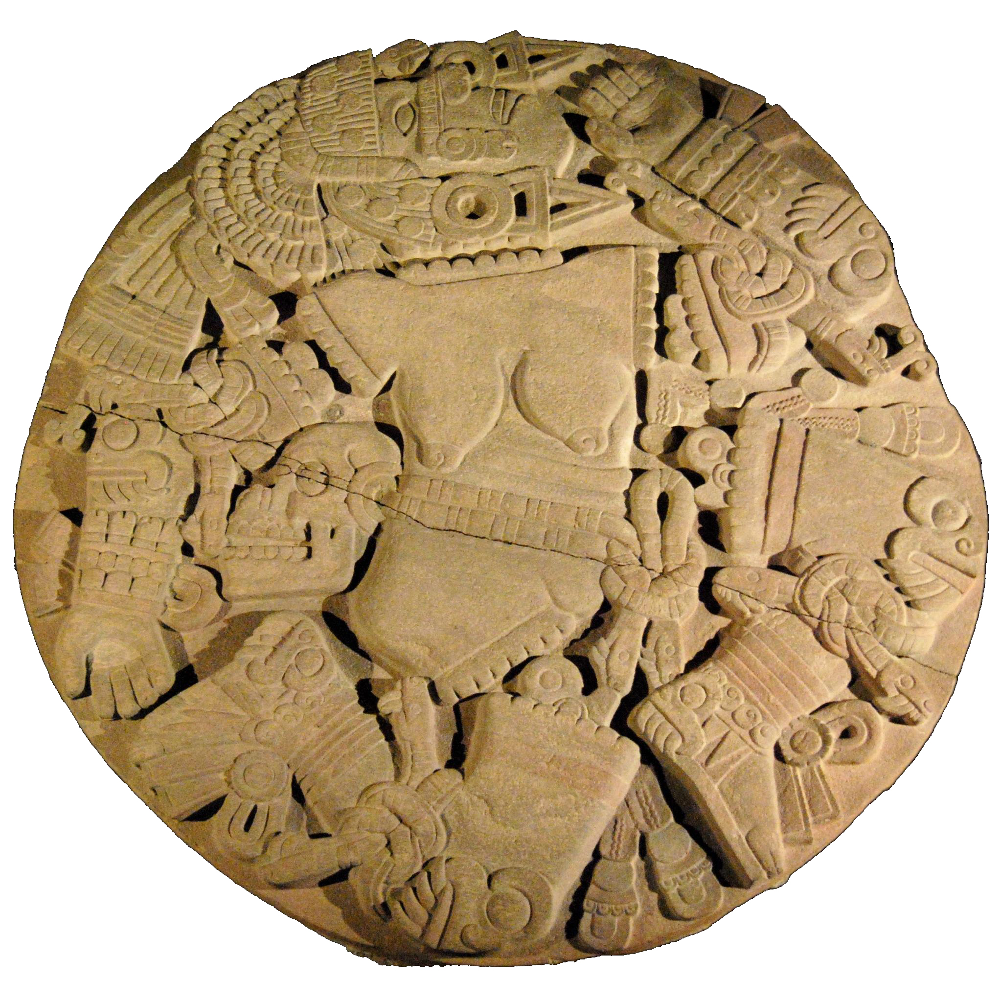

Fig. 9.  3.1 m stone disc of the Aztec Coyolxauhqui goddess of Darkness after http://www.samildan-art.com.

This discovery re-invigorated excavations of the Templo Mayor. These excvations have uncovered may Mezcala figurines that have established it as a repository of Mezcala and other figurines re-appropriated by the Aztecs in their rituals (Batres 1902; Angulo 1966; Contreras 1979; Gonzalez 1986, 1987). Angulo and Contreras in the 1960s described an offering in the structures of the Templo Mayor which contained, among other things, five figurines and five anthropomorphic masks of Chontal style (type 1 of Covarrubias), two masks of type 3 and a small one Model of temple. This offering corresponded to stage IV of the construction of the Templo Mayor. Step IV corresponding to the Recent Postclassic. Gonzalez described thirteen Mezcala offerings in 1978-1980, which were directly associated with the structure of the Templo Mayor. A total of 321 anthropomorphic hard stone figurines were excavated of which

- 78 % are clearly linked to the "local" group (Mezcala in the strict sense)

- 17% to the Teotihuacan Group

- 5 % cannot be included in any category

These finds clearly establish the fact that Aztecs were using Mezcala statuettes and masks as offerings to the deities of fertility, especially Tlaloc.

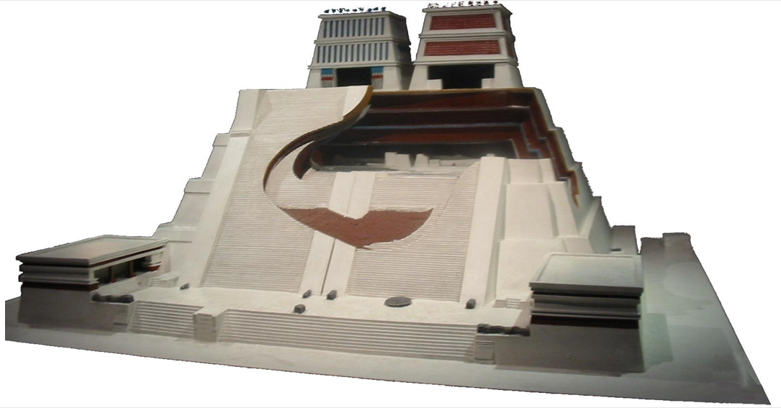

Fig. 10. Model of Templo Mayor with steps that measured 80 m by 90 m at the base, after [http://www.samildan-art.com](http://www.samildan-art.com/).This archaeological reconstruction is exhibited at the [Museo del Templo Mayor](http://www.templomayor.inah.gob.mx/) in Mexico City.

The Aztec Templo Mayor was built on seven earlier pyramids. Stage I corresponds to the oldest pyramid; stage VII to the most recent pyramid. The Mezcala style statuettes and masks were discovered in Stage IV, dating to the Post-Classic Period, 1200-1450, which is contemporaneous with the emperors Moctezuma I and Axayacatl. Within this Period spectacular images were produced, such as the great braziers that bear the visage of Tlaloc, God of water and fertility, Huitzilopochtli, God of war and the sun, and the bas-relief of the Queen of Darkness. 321 anthropomorphic representations have been excavated in Templo Mayor associated with deities of fertility, especially Tlaloc (Gonzalez 1987).

4) The El Mirador site in the Cocula Valley was excavated in early 1986 by Cabrera who discovered two Mezcala figurines associated with a habitation and pottery of the Recent Classic (type 2 of Covarrubias).

5) Teopantecuanitlan was excavated in early 1980 in which two limestone Mezcala figurines were discovered. They were found on the surface of a structure belonging to the third stage of construction of the site, between 800 and 600 BCE.

6) Ahuinahuac (99 ° 32 ' W, 17 ° 56 ' N) was excavated from 1989-1990. 7 Mezcala figures were discovered. The site is two km downstream from the modern village of San Juan Tetelcingo, municipality of Tepecoacuilco in the State of Guerrero.

The site, which overlooks the Balsas River is on a steep slope with a vertical drop of 15 m. It

has architectural and artefactual remains over most of its surface of approximately 200 m by 200 m. Surface samples show two different occupations, one in the north and the other in the south.

Two trenches, one along the axis of the terrace and the other perpendicular to the latter, uncovered six of the seven Mezcala objects within a two-meter radius at Operation 6. These pieces consist of four masks and two figures. They are all anthropomorphic and are shaped in a metamorphic stone of a greenish gray marbled with white.  Five pieces: the four masks (3D4, 6D2, 6B1 and 4F1) and the figurine (4G2) form a very homogeneous ensemble. The small figurine (4B1) was distinguished from the others because of its more detailed shaping.

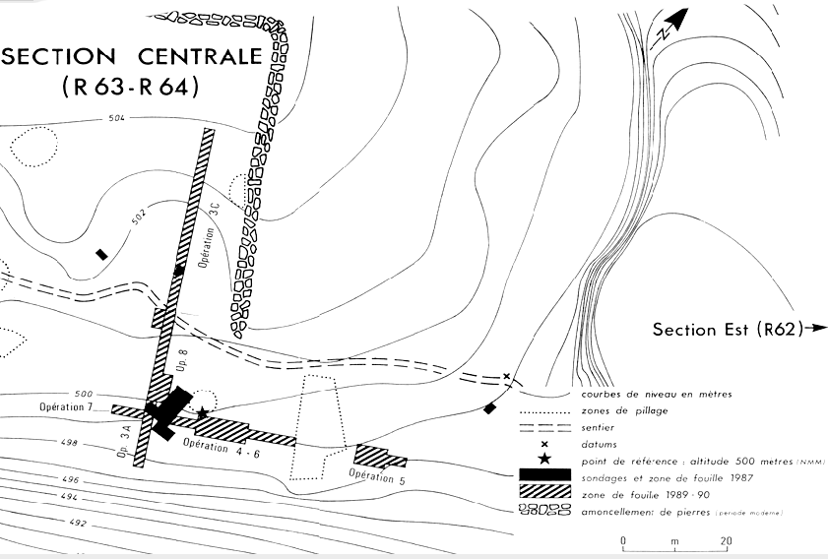

 Fig. 11. Site of Ahuinahuac, after http://www.samildan-art.com.

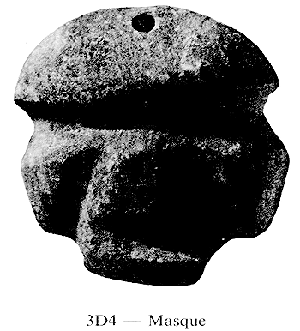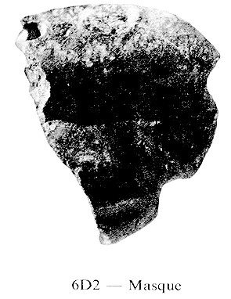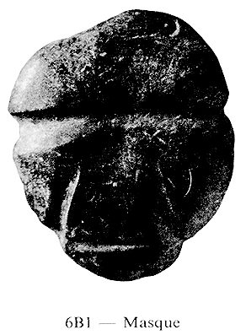

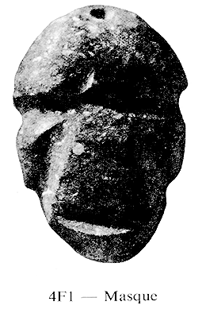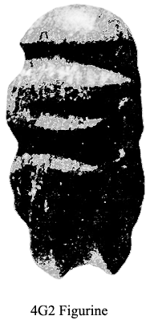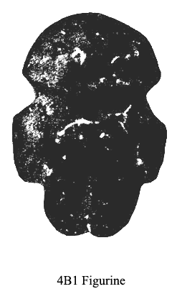 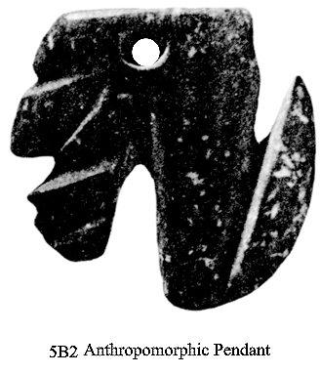

Fig. 12. a-f. Four Mexcala maskettes, two Mezcala figurines and one Mezcala anthropomorphic pendant. after http://www.samildan-art.com.

Four Mexcala maskettes and two Mezcala figurines were excavated, at various depths, inside a thick embankment associated with the demolition of buildings and redevelopment of the terrace. These stone offerings were probably deposited to highlight significant changes in the historical development of the site. The seventh Mezcala piece, 5B2, is an anthropomorphic silhouette pendant, which was discovered in an embankment during Operation 5. It may be an amulet of an ancestral figure as it is unique. It was misidentified in the site report as being an animal pendant.

Ahuinahuac is important because it is the only controlled Mezcala excavation that allows some level of relative dating. It is located on the right bank of the Balsa River, on alluvial terraces with these stone figurines deliberately buried in an embankment that served as the basis for the construction of new housing structures. While is difficult to know the precise motive of this gesture of burying artifacts, these offerings were deposited during new housing construction on top of the existing mound and as such a ritual to consecrate the addition may have included these figurines and maskettes.

**References:**

Covarrubias, Miguel, William Spratling, André Emmerich. 1956. *Mezcala, Ancient Mexican Sculpture*. Andre Emmerich Gallery.

Gay, Carlo, Frances Pratt; Gaston Burnand. 1992. *Mezcala-Ancient Stone Sculpture from Guerrero Mexico.* Geneva, Switzerland; Balsas Publications.

Griffin, Gillett G. 1972. “Xochipala: The earliest great art style in Mexico,” Proceedings of the American Philosophical Society 116 (4): 301–309.

Niven, William. 1897. “Omitlán, A Prehistoric City in Mexico,” Journal of the American Geographical Society of New York, 29(2): 217–222.

Paradis Louise Iseut, Belanger Сhristian, Raby D., Ross B. 1990. “The Mezcala style discovered in context in Guerrero (Mexico)” *Journal of the Society of Americanists*, 76: 199-212.

Paradis, Louise Iseut. 1981, ‘Guerrero and the Olmec’ In The Olmec and their Neighbors, Edited by: Stirling, Matthew Williams, Coe, Michael D., and Grove, David C., pp: 195–208, (Washington D.C.: Dumbarton Oaks

Reyna Robles, Rosa María. 2003. *La Organera-Xochipala: Un sitio del Epiclásico en la Región Mezcala de Guerrero.* Mexico City, Mexico: Instituto Nacional de Antropología e Historia.

Reyna Robles, Rosa María. 2006. "La Organera-Xochipala, Guerrero," *Arqueología Mexicana*, XIV: 82.

Uzu, Charlotte. 2000. *Les figurines en terre cuite de la région Tepecoacuilco-Balsas Guerrero, Mexique*. [Montréal]: Université de Montréal.